- Найдите все порядковые числительные (их семь)
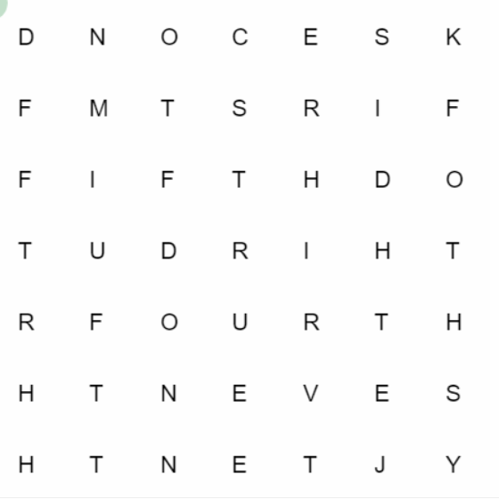
- Заполни пропуски порядковыми числительными (по примеру)
Пример: February is the 2nd month of the year.
1. January is the _______ month of the year.

2. March is the __________ month of the year.

3. July is the ___________ month of the year.

4. August is the __________month of the year.

5. October is the ___________ month of the year.

6. December is the __________ month of the year.

